Department of Trade and Taxes

Government of NCT of Delhi

Form WC 01

[See notification under section 16(12)]

(PART-A)

Application Form for opting Composition by an eligible works contractor in respect of scheme as notified by Government under sub-section (12) of section 16

Ward No.

1. TIN

- Full Name of Applicant Dealer

- Full Address of Dealer

4. | Year with effect from which composition scheme is sought* |  |  |  |  |  |  |  |  |  |  |  |  |  |  |  |  |  |  |  |  |  |  | -
 | * hereinafter referred to as “current year”
5. Applicable rate of composition amount** |  |  |  |  |  |  | 2.5% |  |  |  |  |  |  |  |  |  |  |  |  |  |  |  | 3%
 |  |  |  |  |  |  | of the turnover |  |  |  |  |  |  |  |  |  |  |  |  |  |  |  |  | of the turnover
 | ** please tick in the appropriate box
6. | Turnover in the preceding year |  |  |  | (Rs.)
7. | Estimated Turnover in the current year |  |  |  | (Rs.)
8. | Tax Payable on |  |  |  | Description* |  |  |  |  |  |  |  |  |  | Tax Payable (Rs.)
(i) Opening Stock |  | held | on the
 |  | held | on the | (i) Trading Stock
 | first day with effect from
 |  |  |  | (lii) Raw material
 | which scheme is being opted
(ii) Capital Goods (in respect of |  |  |  | (iii) Packaging Material
 | which ITC has been claimed
 |  |  |  | (iv) Finished Goods
 | in preceding | three | years,
 | in preceding | three | years, | (v) Capital Goods
 | which is to be reversed)
 |  |  |  |  |  |  | Total
 | (* Please complete Part B)

9. Details of Tax paid calculated | Description
as per (8) above
as per (8) above | (i) Amount of tax paid* (Rs.)
 | (iii) Date of Deposit |  |  | / |  |  | /
 |  | dd |  |  | mm |  |  |  | yyyy
 | (iii) Challan No. if any
(* Please attach original challan / proof of deposit)
 | Name and signature of applicant / authorized signatory

9. Verification

I/We __________________________________________ hereby solemnly affirm and declare that the information given hereinabove is true and correct to the best of my/our knowledge and belief and nothing has been concealed therefrom.

Signature of Authorised Signatory | ____________________________________
Full Name (first name, middle, surname) | ____________________________________
Designation | ____________________________________

Place

Date

Day | Month | Year

Department of Trade and Taxes

Government of NCT of Delhi

Form WC 01

[See notification under section 16(12)]

(PART-B)

Details of the Stock held on the first day [i.e. on _____________(date)] of the period for which the composition is sought

(i) Details of Trading Stock

Rate wise details of the Trading Stock

- Goods taxable at 1%

- Goods taxable at 4%

- Goods taxable at 12.5%

- Goods taxable at 20%

E Total

Purchase Value
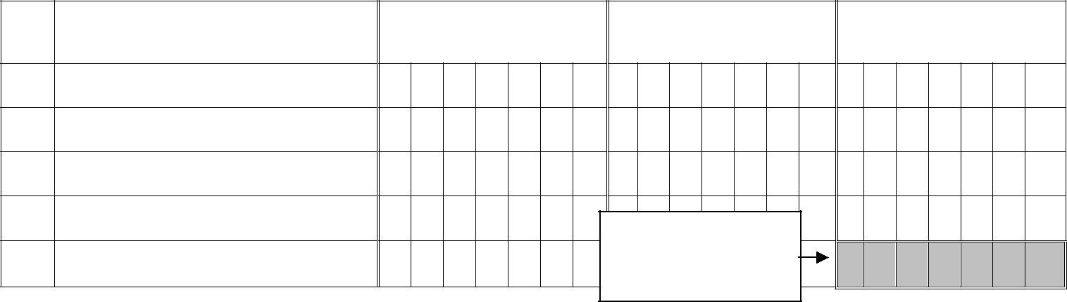
(Rs.)

Fair Market Value* | Tax Payable (Rs.)
(Rs.)
Carry to field
(7)(i) of part A

(* As at opening day of the period for which is being opted)

(ii) Details of Raw Material

Rate wise details of the Raw Material

- Goods taxable at 1%

- Goods taxable at 4%

- Goods taxable at 12.5%

- Goods taxable at 20%

E Total

Purchase Value
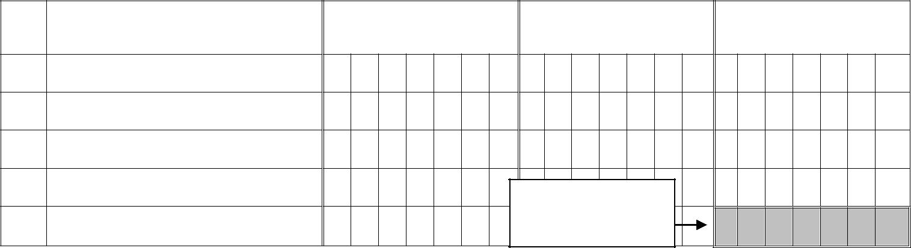
(Rs.)

Fair Market Value* | Tax Payable (Rs.)
(Rs.)

Carry to field

(7)(ii) of part A

(* As at opening day of the period for which is being opted)

(iii) Details of Packaging Material

 | Rate wise details of the | Purchase Value | Fair Market Value* | Tax Payable (Rs.)
 | Packaging Material | (Rs.) | (Rs.)
A | Goods taxable at 1%
B Goods taxable at 4%
C Goods taxable at 12.5%
D | Goods taxable at 20% |  | Carry to field
E | Total |  | (7)(iii) of part A
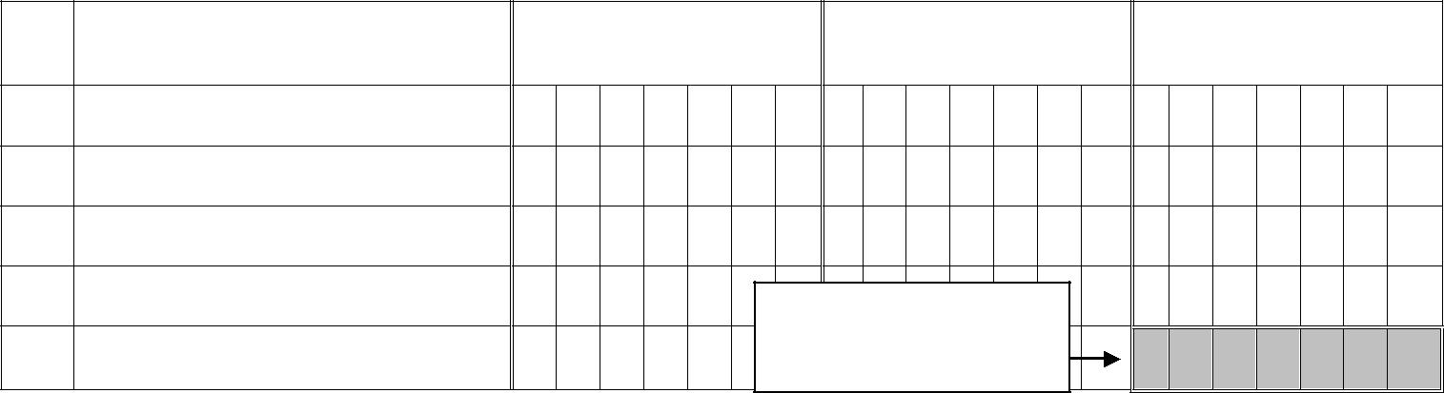
(* As at opening day of the period for which is being opted)

(iv) Details of Finished Goods

 | Rate wise details of the | Purchase Value | Fair Market Value* | Tax Payable (Rs.)
 | Finished Goods | (Rs.) | (Rs.)
A | Goods taxable at 1%
B Goods taxable at 4%
C Goods taxable at 12.5%
D | Goods taxable at 20% |  | Carry to field
E | Total |  | Carry to field
E | Total |  | (7)(iv) of part A
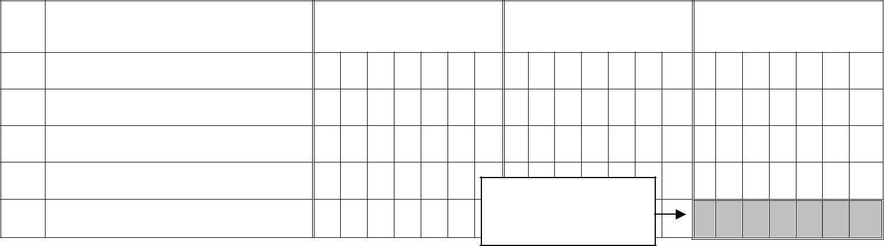
(* As at opening day of the period for which is being opted)

(v) Details of Capital Goods

Rate wise details of the | Purchase Value | Fair Market Value* | Tax Payable in
Capital goods | (Rs.) | (Rs.) | consequence of
 |  |  | reversal of ITC
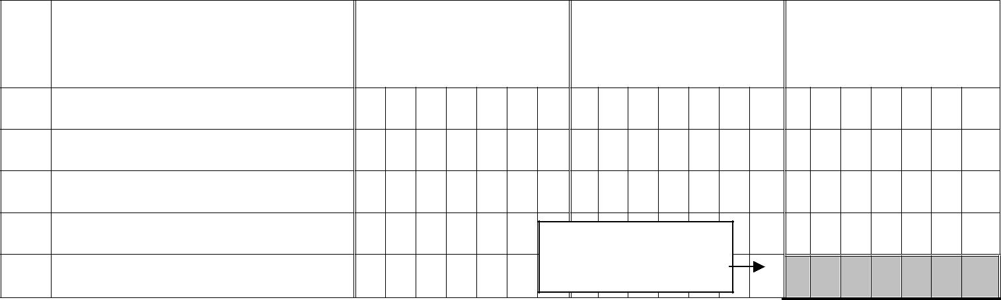
A Goods taxable at 1%
B Goods taxable at 4%
C Goods taxable at 12.5%
D Goods taxable at 20% |  | Carry to field
E | Total | (7)(v) of part A

(* As at opening day of the period for which is being opted)

Name and signature of applicant / authorized signatory

vi. Verification

I/We __________________________________________ hereby solemnly affirm and declare that the information given hereinabove is true and correct to the best of my/our knowledge and belief and nothing has been concealed therefrom.

Signature of Authorised Signatory | __________________________________
Full Name (first name, middle, surname) | __________________________________
Designation | __________________________________

Place

Date

Day | Month | Year

